|  |  |  |
| --- | --- | --- |
| **Time** | **Topic** | **Presenter** |
| 10:00 a.m. | Welcome and check-in  Rustad Rec Center  601 26th St E  West Fargo, ND 58078 | *Sheryl Beard, President of ALL* |
| 10:05 am | Board Updates:  Financials  Bylaws  Board Member Updates  Advocacy Opportunities around ND  Conference Discussion-speaker ideas  Fundraising ideas | ALL Board Members |
| 10:30 | Voting training  Rights-learn them and use them!  Abuse/Neglect/Exploitation training | Protection and Advocacy Project |
| 12:00 | Lunch! Taco Bar |  |
| 12:30 | Facilitated Work:  Business owners and local legislators will come to help you practice delivering your story and talk about employment!  Get ready to mingle and learn! | Patrick Kirby |
| 2:00 | Adjourn!  Next Meeting: Thursday, September 26, 2024  12-6 p.m.  Minot Zoo! Minot, ND |  |

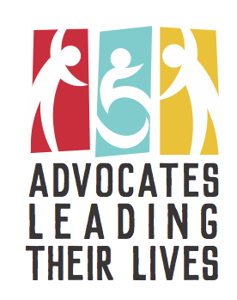Register here for the meeting: https://forms.gle/69edmh7CC4QpxZei8

Email Julie for assistance [jhorntvedt@nd.gov](mailto:jhorntvedt@nd.gov) or call 701-328-4847

Hotel rooms and rides can be provided. You must fill out the registration form by June 7th to secure a room.

Fill out the registration form to let us know if you need a ride, dietary restrictions, or any accommodations. We will contact you for arrangements.

We provide meals during training and reimburse the meals that are not provided. Mileage is also reimbursed at state rate for staff who provide rides. A form will be provided at the meeting.