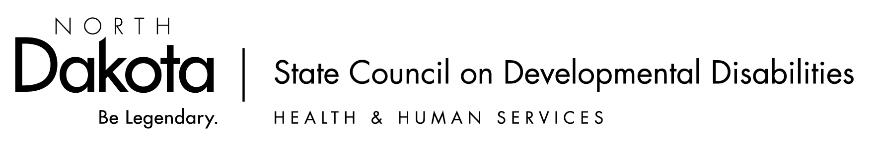

The mission of the NDSCDD is to promote and create positive change for people with developmental disabilities and their families.

Date: August 25, 2025 10:00 a.m.-3:00 p.m. (Central Time)

Location: Microsoft Teams

DD Council Meeting | Meeting-Join | Microsoft Teams

Dial in by phone
+1 701-328-0950,,714405466#

General comments from the public attending the meeting will be taken during the meeting.

Time | Event/Topic | Purpose/Person | Action
10:00 | Call the meeting to order; roll call & introduce guests | Determine members who are present / absent.
10:05 | Meeting Minutes | Approve May, 2025 minutes | Motion/Vote to Approve or Change
10:15 | Introduction of New Members and Staff | Meet Lorena Poppe, Sadie YoungBird, and new staff-Kasi Kautz | Council member introduce themselves too  Find a mentor for new Council Members
10:30 | Director’s Report | Social Media Policy  Strategic Plan 2025  SMART Goals State Plan  Updates to Board Positions  Trevor-Find a new Council rep for Consumer Advisory Council  Budget Update | Council discussion/Questions  Motion/Vote to Approve or Change
11:00 | Region 8 Reporting | Meet the DD Council Directors from SD, CO, and UT to talk about their future state plan work | Council discussion/Questions
12:00 | Lunch |  | Grab Your Lunch and prepare for a  Listen and learn
12:15 | Eric Gault | Leadership and Learning Grant Report | Council members listen/questions
12:30 | Carl Young | Report on FASD Work Federally  Report on Recording of the FASD Video Series  Advocacy next steps: interim session, CDAC | Council members listen/questions
1:00 | State Plan Work | Patrick Kirby, Facilitation | Council will brainstorm, and work  On SMART Goals  - Plan on Fall/Winter town halls  - Gathering Public Input  - Motion/Vote as needed
2:45 | Member Share | Council Members provide updates | Listen
3:00 | Adjourn

Recuse -- to declare yourself to be, disqualified to judge something or participate in something because of possible bias or personal interest.

- A Council member who is affiliated with an entity applying for or receiving funds shall abstain from deliberation and voting about awarding, withholding, or terminating grant funds. This policy also applies to any Council member who is a family member of someone affiliated with an entity that is applying for Council funds.

- A Council member shall abstain from deliberation and voting on policy positions when the agency he or she represents is affected by that NDSCDD policy position.

- A Council member must declare any potential conflict of interest and disqualify himself or herself from deliberation and voting on a grant award or policy position when those conflicts of interest occur. Such abstention from voting shall be noted in the meeting Minutes.

“Per our policies, the Council must make sure that no member or staff receives or creates the appearance of financial or personal gain in any amount from Council actions.

Therefore:
No Council member or staff shall participate in the discussion, selection, or vote of a grant or contract where the member or staff is involved, financial interest or personal gain in the activities of the grant or contract.

Also:
No member or staff shall share confidential information acquired during official Council duties in advance of its authorized release to the public.

**If you feel you may have a conflict of interest, please excuse yourself from this discussion and/or leave the room during this agenda item.”

