COVER SHEET
- Institution’s Name:
- Date Submitted:
- Preparer of this Report:
  - Phone:
  - E-mail:
- CAEP/State Coordinator:
  - Phone:
  - E-mail:
- Name of Institution’s program:
- Grade levels for which candidates are being prepared:
- Degree or award level (select one)
  - Initial
    - Baccalaureate
    - ___ Post Baccalaureate
- Is this program offered at more than one site?
  - ___ Yes
  - No
- If your answer is yes to the above question, list the sites at which the program is offered:
- Program report status (check one):
  - ___ Initial Review
  - ___ Continuing Review
  - ___ Focused Visit

SECTION I: CONTEXTUAL INFORMATION
- Candidate Information

Directions: Provide three years of data on candidates enrolled* in the program and completing** the program, beginning with the most recent academic year for which numbers have been tabulated. Please report the data separately for the levels/tracks (e.g., baccalaureate, post-baccalaureate, alternate routes, master’s, doctorate) being addressed in this report.

Program:
Academic  Year | # of Candidates Enrolled in the  Program | # of Program  Completers
* Enrolled candidates are those formally admitted to the program as of the institution's official fall reporting date or as of October 15 of each academic year.
** Program completers are those candidates for whom a degree is conferred within the selected academic year. The academic year begins in the fall and concludes in the spring or summer of the following year depending upon whether candidates are granted degrees in the summer.
- Curriculum Exhibit (Select 1)
  - ___ Option 1: Complete the Curriculum Exhibit Form below. Include an electronic link to each syllabus for courses listed under the Teaching Specialty and the Professional Education columns.
  - ___ Option 2: Upload the Program Status Sheet (must include general studies, specialty area, and professional education courses). Include an electronic link to each syllabus for courses listed under the Teaching Specialty and the Professional Education columns.
Curriculum Exhibit Form SFN 14381. Provides the opportunity for institutions to document the entire program including general studies, teaching specialty, and professional education.
- Curriculum exhibit forms are to be prepared for every basic and advanced program being brought forward for either initial or continuing approval by the Education Standards and Practices Board (ESPB).
- A separate sheet is to be completed for each program for which approval is requested. If more than one program is offered within an approval category, a separate sheet must be completed for each of those programs. For example, if both instrumental and vocal/choral music majors are offered, complete a separate sheet for each. Also, for example, a separate sheet must be completed for each of the science and social science majors.

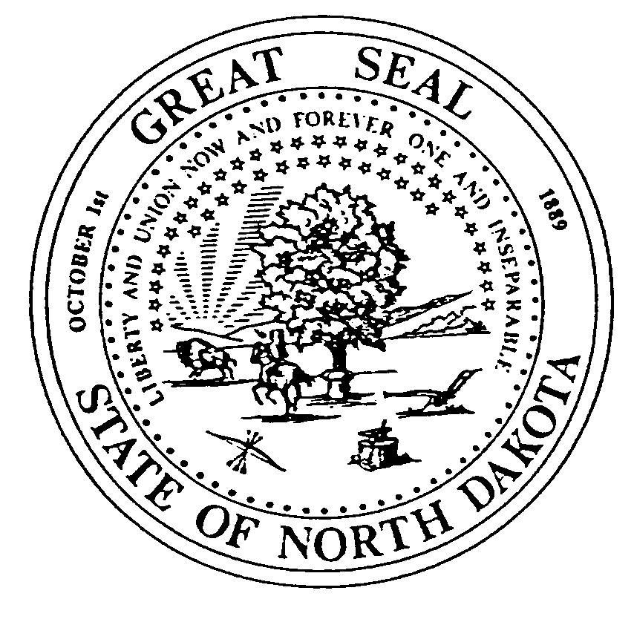
CURRICULUM EXHIBIT FORM BASIC PROGRAM
EDUCATION STANDARDS AND PRACTICES BOARD
SFN 14381 (05-17)

Institution: |  | Major:
Total credits required for degree:
General Studies | Teaching Specialty | Professional Education
Credits Required: | Credits Required: | Credits Required:
Total: | Total: (Minimum 32 hours) | Total: ( Minimum 22 hours Including Student Teaching)

ESPB does not advocate, permit, nor practice discrimination on the basis of sex, race, color, national origin, religion, age or disability as required by various state and federal laws.
- Descriptive Information about the Program: Provide a one to two paragraph description to help reviewers understand your program (include information the describes how a student typically moves through the program from entry to exit).
- Changes in the Program since the Last Review: Please describe any changes since the last review and include rationale for those changes.
- Field & Clinical Experiences: Briefly describe the required field & clinical experiences that are specific to your program including the number of hours for early field experiences and the number of hours/weeks for student teaching or internships.

SECTION II: RESPONSE TO STANDARDS

- Areas of Weakness from Prior Review: How has the program addressed and resolved the weaknesses targeted in the previous program review and not previously resolved? Describe actions taken to address the weakness and provide evidence that the weakness has been resolved.
- Course/Assessment Matrix:
- Complete the matrix below.
- List courses that address each of the ESPB standards for your program.
(All courses listed should be linked to an electronic syllabus.)
List the assessments that most clearly align with each standard.
- (Choose from among those listed in Section IV: Evidence of Meeting the Standard).
- Provide a short narrative describing how the program addresses the standard.
(For example, identify course objectives, activities and related experiences.)
SECTION III: ADDRESSING THE STANDARDS
State Standard | Course Prefix and Title (with electronic links to syllabi) | Assessment (from among those listed under Section IV : Evidence of Meeting the Standard)
12005.1 Content Knowledge. The program requires the study of music education content and disciplinary concepts related to the development of a musically educated person. To meet this standard, institutions will require:
A. Knowledge and skills in the use of basic vocabulary of music.
B. The program requires study and experiences designed to develop the following: (a) basic conducting skills, score reading, and rehearsal techniques; (b) ability to compose, arrange, and adapt music from a variety of sources to meet the needs and ability levels of school performing groups and classroom situations; (c) ability to guide creative experiences and improvise in an extemporaneous performance; (d) proficiency on piano, guitar, or other appropriate keyboard or fretted instruments sufficiently advanced for demonstration and accompaniment; (e) advanced ability sufficient to assure accurate and musically expressive performance; and (f) ability to perform in large ensembles and a variety of small ensembles.
C. The ability to analyze the role of music within a variety of cultures and historical periods and its impact on society.
D. The ability to relate to various types of music knowledge and skills within and across the arts.
Narrative:
Programs directed toward preparing teachers for either vocal/choral or instrumental must meet either 12015.1a and 12015.1b or 12005.1 c and 12005.1d as well as the other standards.

12005.1c Instrumental music program. The instrumental music program requires study and experiences designed to develop the following: (a) knowledge of and performance ability on wind and percussion instruments; (b) knowledge and performance ability on keyboard and fretted instruments sufficient to employ these instruments as teaching tools; and (c) basic knowledge of instrumental problems and strategies as well as sufficient performance skill to assure effective use of the major instrument in demonstrating instrumental technique.
Narrative:
12005.1d Instrumental music program. The instrumental music program requires experiences in the following: (a) performing on an instrument in solo as well as in small and large ensembles; (b) using the singing voice as a teaching tool and conducting choral as well as instrumental ensembles; and (c) teaching instrumental students individually as well as in small and large groups.
Narrative:

12005.2 Pedagogical Knowledge. The program requires the ability to apply pedagogical knowledge and skills appropriate to the teaching of music including the ability to perform, transpose, and improvise on keyboard and fretted instruments sufficient to employ these instruments as teaching tools. The core of this standard will be a series of sequential and progressive field experiences/student teaching that allow teacher candidates to refine, extend, and apply their teaching skills at the B‐3, 1-8, 5‐8, or 5‐12 levels.
Narrative:
12005.3 Growth and Development. The program requires the study of how individuals learn and develop, and how teaching candidates can support their students’ physical, cognitive, social, and emotional development. This standard addresses human growth and musical development and focuses on the application of growth and development concepts necessary to create learning experiences such as the development of fundamental motor skills, which may include bilateral and cross lateral development and vocal and instrumental technique. Teacher candidates will demonstrate the ability to plan and implement developmentally appropriate learning experiences based on expected developmental levels.
Narrative:
12005.4 Diverse Learners. The program requires the study of how individuals differ in their approaches to learning and creates appropriate instruction adapted to these differences. Through this standard, teacher candidates demonstrate their ability to plan and implement learning experiences that are sensitive to diverse learners, and that will enable learners to develop qualities of respect and responsibility. The program requires study of state and federal laws dealing with the education of students with special needs (e.g. gender equity and the needs of gifted and special needs students.)
Narrative:

12005.5 Management and Motivation. The program requires the study of individual and group motivation and behavior to create a safe learning environment, recognizing legal responsibilities and encouraging positive social interaction, active engagement in learning, and self‐motivation. This standard is concerned with the teacher candidate’s use of a variety of strategies to institute behavior change, manage resources, promote mutual respect, and self-responsibility, and motivate students. Teacher candidates whose performance is acceptable will be effective in helping learners develop behaviors related to respect, responsibility, and enjoyment of musical activities.
Narrative:

12005.6 Communication. The program requires the study of effective verbal, nonverbal, and media communication techniques to enhance learning and engagement in musical settings. Teacher candidates demonstrate sensitivity to all learners, and model appropriate behavior.
Narrative:
12005.7 Planning and Instruction. The program requires the study of how to plan and implement a sequential standards‐based K‐12 curriculum using a variety of developmentally appropriate instructional strategies.
Narrative:

12005.8 Learner Assessment. The program requires the study, observing, recording, and reporting of assessment to foster musical, cognitive, social, and emotional development of learners in musical activity. Teacher candidates will use various forms of authentic and traditional assessment to determine achievement, provide feedback to students and parents, and guide instruction. Critical to this process will be an analysis of the appropriateness of various assessments.
Narrative:
12005.9 Reflection. The program requires the study of reflective practice, with evaluation of the effects of the educator’s actions on others (e.g., learners, parents/guardians, fellow professionals). Teacher candidates seek opportunities to grow professionally. This standard can be met through a series of learning experiences that promote self‐reflection on the part of teacher candidates.
Narrative:
12005.10 Technology. The program requires the study of current, appropriate instructional technologies to enhance learning and to enhance personal and professional productivity.
Narrative:
12005.11 Collaboration. The program requires the study of how to foster relationships with colleagues, parents or guardians, and community agencies to support learners’ growth and well‐being. This standard encompasses the teacher candidate’s opportunities to interact and advocate for music education both in school and the larger community. Inclusion of learning experiences that involve teacher candidates with community agencies would be appropriate.

Narrative:
SECTION IV: EVIDENCE OF MEEETING THE STANDARDS
It is expected that your program makes use of multiple assessments to ensure that all standards are met. If the program is offered in more than one site or in more than one method (e.g. online as well as face-to-face) provide aggregated (program level) AND disaggregated (site or method specific) data. Complete tables 1.A-1.D described below and provide information requested related to the two-four additional assessments you selected in 2.
1. Required Assessments:
1. A Praxis II: Content Test: Complete Table 1.A reporting at least 3 years of data
[Enter Data Collection Start and End Dates Here]
Content Area Test Name and Number | ND Passing Score | Total # of Test Takers | Average Score | Percent Passing

1. B Praxis II: PLT (Principles of Learning and Teaching): Complete Table 1.B reporting at least 3 years of data
[Enter Data Collection Start and End Dates Here]
Content Area Test Name and Number | ND Passing Score | Total # of Test Takers | Average Score | Percent Passing

1. C Cumulative GPA at the point of completion: Complete Table 1.C reporting at least 3 years of data (Courses included in the calculation must be required for all candidates.)
Year | N (number of candidates) | Overall Average GPA | Range of GPA
1. D Student Teaching Performance (Clinical Experience) Evaluation (please report data only in the area of content knowledge).
      - Build Table 1. D that includes the following:
        - The N (number of candidates)
        - Proficiency scale (e.g. Beginning, progressing, proficient, exceeds proficient)
        - Performance results at each proficiency level (at least 3 years of data)
      - Attach an electronic copy of the performance instrument

2. Additionally, select from among the following assessments for a total of 6-8. Provide a description of the assessment, a data table showing three years of results, an electronic copy of the assessment instrument (test, project, paper, etc.) and, where appropriate, the rubric or scoring guide.
    - Pre-student Teaching Practicum Evaluations
    - Key Performance Tasks
    - Capstone Project (portfolio, teacher work sample, etc.)
    - Employer survey results related to content knowledge
    - Graduate survey results related to content knowledge
    - Additional assessment of choice

3. Respond to the following questions:
    - Analysis of findings: Describe how the data provided above demonstrate that candidates in the program meet the standards.
b. Response to findings: What changes have you made in your program as a result of data analysis? Provide a rationale for your decision.

