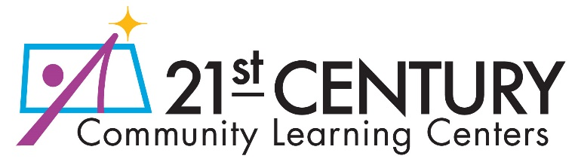

Non-Public School Consultation Form
All subgrantees/fiscal agents receiving funds under the Title IV, Part B, 21st CCLC grant program must, after timely and meaningful consultation with appropriate officials of nonpublic schools located in the area served by the subgrant, provide to nonpublic school children and educators educational services and other benefits that are equitable in comparison to such services and other benefits provided with program funds to public school children and educators. (Every Student Succeeds Act of 2015, Section 8501(a)(1), (3)(A)).
Before subgrantees/fiscal agents make any decision that affects the opportunity of eligible nonpublic school children, teachers and other educational personnel to participate, the subgrantee/fiscal agent shall engage in timely and meaningful consultation with nonpublic school officials. The requirement to provide for the equitable participation of nonpublic school children and educators applies regardless of whether a subgrantee is an LEA, CBO, or other eligible entity.
NDDPI collects this information on an annual basis for all current subgrantees/fiscal agents. This completed document must be kept in your records and available to NDDPI upon request.
Subgrantee/Fiscal Agent: |  | Program Director:
Please complete the following form related to the involvement of eligible nonpublic schools in the 21st CCLC grant program for which you are the subgrantee/fiscal agent.
- There are no nonpublic schools located within the attendance zone of the targeted school(s) that serve the same age/grade span(s) as the target student population for the 21st CCLC program. (If there are no nonpublic schools in your attendance zone, no further information is required.)
- There are nonpublic schools located within the attendance zone(s) of the targeted school(s) that serve the same age/grade span(s) as the target student population for the 21st CCLC program, and these schools (listed below) have been consulted as either:
- part of the most recent annual Federal Program Consolidated Application submission by the LEA(s) of the recipient school(s),
OR
- the annual consultation process followed by the 21st CCLC subgrantee/fiscal agent.
Nonpublic school(s) in the attendance zone(s) that serve the same age/grade span(s) as the target student population of the subgrantee/fiscal agent 21st CCLC recipient school(s):
[add rows as needed]

